Lab3 Deliverables

- Objectives
The purpose and objective of this lab was to implement and test the performance of a priority scheduler and blocking semaphores. The performance measurements were to be tested using a Jitter measurement and the priority and blocking were tested using several test cases that checked for starvation and basic performance.
- Hardware Design
There was none, move along, nothing to see here… (steals baby monkey)
- Software Design
Procedure 2: see debug.c for jitter related functions
Procedure 4: see main at the bottom of lab3.c
All other relevant files: see zip file
- Measurement Data
Round Robbin
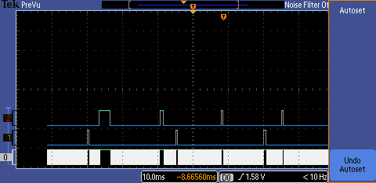

Priority
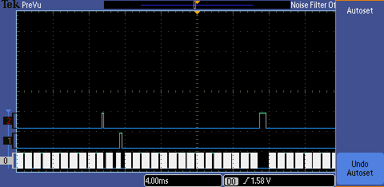

Table like Table 3.1
[so there’s supposed to be a table here, but there isn’t. I have run out of time and need to go do the prep for lab 5 now so im cutting my losses and moving on.]

- Analysis and Discussion
  - Our current implementation of OS_AddPeriodicThread doesn’t allow for more than 8 threads, 2 on each of the 4 timers, to do more than that we would have to implement a periodic background thread that had counters for each virtual thread, allowing us to have 1 actual thread with multiple thread triggers based on counters that would be multiples of the hardware trigger time.
  - It wouldn’t, our current implementation puts each blocked thread into a blocked list associated with each semaphore, so it’s right there to be unblocked, and it has bounded waiting. So our implementation is fully scalable.
  - I would probably periodically bubble sort them in a heap instead of looping through the entire list each time, this would save time and allow for easiest access to the next thread.
  - If all threads are blocked then the thread switch will just sit there searching for a thread, it would not crash. If all the threads are sleeping the OS will not crash, it would simply go into a holding pattern until a thread came out of sleep mode.
  - It doesn’t crash, it causes a call to OS_SysTickHandler to switch the threads out.
  - If you just need to wait a little while then the spinlock semaphores are best because they will hold you in place until the resource is free, however if it is going to be a long time then blocking semaphores are best because they surrender the remainder of the time that the thread would consume and allow the next thread to go ahead and start earlier, thus speeding up the system overall.
  - I don’t wana 1-(n/m!)

